**Lecture # 6:**

**Objective:**

* Employee Salary Example
* Exception Handling
* Use of Check Box
  + Coffee Shop Example
* Use of Radio Button
  + Background and Fore color Example

# Employee Salary

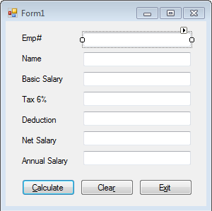

using System;

using System.Collections.Generic; using System.ComponentModel; using System.Data;

using System.Drawing; using System.Linq; using System.Text;

using System.Windows.Forms;

namespace EmployeeForm

{

public partial class Form1 : Form

{

float bsal, tax, deduction, nsal, asal;

public Form1()

{

InitializeComponent();

}

private void btnCalculate_Click(object sender, EventArgs e)

{

if (txtEmpNo.Text == string.Empty)

{

MessageBox.Show("Employee Number"); txtEmpNo.Focus();

}

else if (txtName.Text == string.Empty)

{

MessageBox.Show("Name"); txtName.Focus();

}

else if (txtSalary.Text == string.Empty)

{

MessageBox.Show("Salary"); txtSalary.Focus();

}

else if (txtDeduction.Text == string.Empty)

{

MessageBox.Show("Deduction"); txtDeduction.Focus();

}

else

{

try

{

}

bsal = float.Parse(txtSalary.Text); deduction = float.Parse(txtDeduction.Text); tax = float.Parse((bsal * 0.06).ToString()); txtTax.Text = tax.ToString();

nsal = bsal - deduction - tax; txtNetSalary.Text = nsal.ToString(); asal = nsal * 12;

txtAnnualSalary.Text = asal.ToString();

catch (Exception ex)

{

MessageBox.Show(ex.Message);

}

}

}

private void btnClear_Click(object sender, EventArgs e)

{

txtEmpNo.Text = string.Empty; txtName.Text = string.Empty; txtSalary.Text = string.Empty; txtTax.Text = string.Empty; txtDeduction.Text = string.Empty; txtNetSalary.Text = string.Empty;

txtAnnualSalary.Text = string.Empty;

}

private void btnExit_Click(object sender, EventArgs e)

{

Application.Exit();

}

}

}

# Coffee Shop:

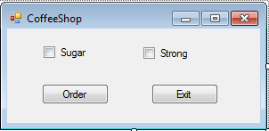

using System;

using System.Collections.Generic; using System.ComponentModel; using System.Data;

using System.Drawing; using System.Linq; using System.Text;

using System.Windows.Forms;

namespace CoffeShop

{

public partial class Form1 : Form

{

public Form1()

{

InitializeComponent();

}

private void btnExit_Click(object sender, EventArgs e)

{

Application.Exit();

}

private void btnOrder_Click(object sender, EventArgs e)

{

string strmsg = "Your Order Includes "; if (chkbxSugar.Checked)

{

strmsg = strmsg + "Sugar ";

}

if (chkbxStrong.Checked)

{

strmsg = strmsg + "Strong";

}

MessageBox.Show(strmsg);

}

}

}

# Change Color

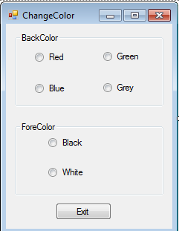

using System;

using System.Collections.Generic; using System.ComponentModel; using System.Data;

using System.Drawing; using System.Linq; using System.Text;

using System.Windows.Forms;

namespace ChangeColor

{

public partial class Form1 : Form

{

public Form1()

{ InitializeComponent(); }

private void btnExit_Click(object sender, EventArgs e)

{ Application.Exit(); }

private void rdbtRed_CheckedChanged(object sender, EventArgs e)

{ this.BackColor = Color.Red; }

private void rdbtGreen_CheckedChanged(object sender, EventArgs e)

{ this.BackColor = Color.Green; }

private void rdbtBlue_CheckedChanged(object sender, EventArgs e)

{ this.BackColor = Color.Blue; }

private void rdbtGrey_CheckedChanged(object sender, EventArgs e)

{ this.BackColor = Color.Gray; }

private void rdbtBlack_CheckedChanged(object sender, EventArgs e)

{ this.ForeColor = Color.Black; }

private void rdbtWhite_CheckedChanged(object sender, EventArgs e)

{ this.ForeColor = Color.White; }

}}